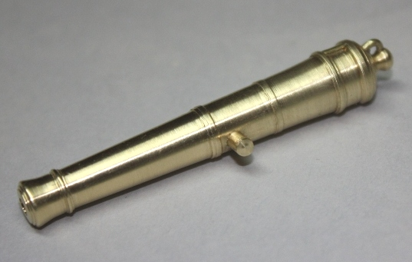
Blomefield began working at artillery design in 1783. His ideas for cannon included a more simple design compared to the Armstrong design, which had been the standard for the Navy since about 1725. He also worked at reducing the overall weight without lessening the strength of the barrel by maintaining the breech robustness but reducing the balance of the material in the barrel. He also added a loop to the cascabel through which the breech line could pass without having to make a loop of this rather large rope. By the late 18th century the Blomefield pattern became the standard for the Royal navy.
There are several methods of producing the cannon barrels
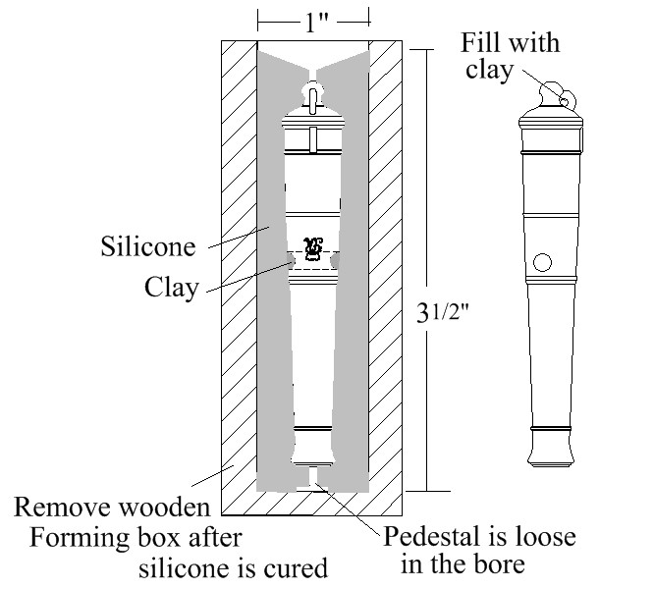
1.) They can be purchased. There are no Blomefield pattern 18 pounders that we have seen offered as a stock size. Most, not all, commercial barrels are not the most accurate reproductions.
2. If the modeler has a wood turning lathe, very fine looking barrels can be made from good quality hardwoods. The more dense and close grained the wood, the better the quality of the turned barrel.
3. If the modeler has a metal turning lathe, a complete set of very accurate barrels can be produced. Turning every barrel on a lathe requires skill and attention to the finest detail to be sure every barrel is exactly the same. Even if the lathe can be set up with a pattern following device, duplicating the barrels can be a challenge. If the builder is fortunate enough to own or can borrow time on a CNC lathe, making a set of identical barrels is not difficult.
4. If the modeler has, or knows someone with a metal turning lathe, one of each size cannon to be made in a few hours and then used to make a mold which is in turn used to cast the cannon barrels.
I chose to cast the barrels for Euryalus for several reasons. I never did it before, and I was given enough pewter to make hundreds of barrels if I chose to use pewter for the casting material. In the end I chose to use casting resin rather than the pewter, mainly because of the added weight that the pewter would contribute. Whether the barrel is made by the builder or purchased, a George III monogram and vent field should be included.
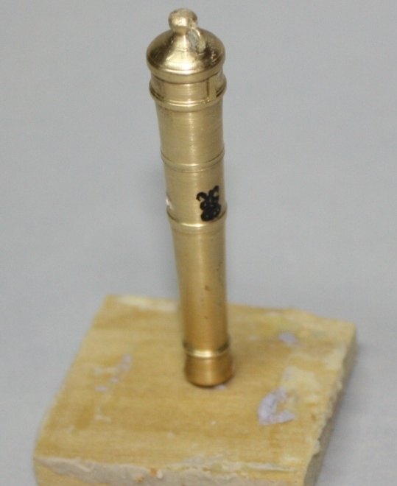
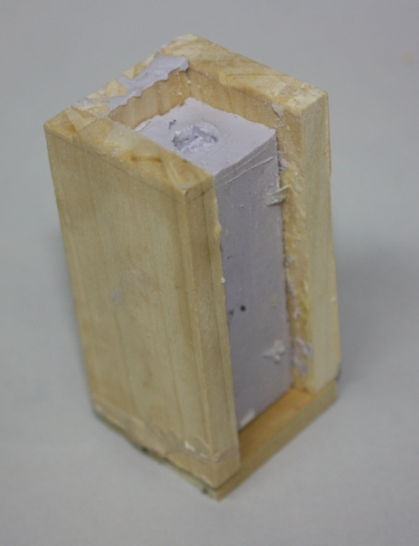
The vent field can be made from most any material and glued to the barrel master. The monogram is most easily made using a fine lining paint brush and a viscous acrylic paint. Paint the monogram and let it dry. Paint a second layer and it will stand out sufficiently to be seen even by the casual observer. Photoetched monograms can also be used, but attaching them to the barrel may be problematic. Getting enough heat to the barrel to silver solder is difficult. Epoxy is messy and will fill in the gaps in the monogram, and cyanoacrylate glues are not totally proven to last in many minds.
Regardless of the barrel material, the mold making process is the same. This process is described in great detail in several books and articles and generally follows the same procedure, that is, making the mold in two halves using silicone mold materials. There are hundreds of silicones, but the key is to use silicone that can hold up to the temperatures of molten pewter or similar low melt point metals and/or the chemicals found in casting resins. I found that no matter how attentive I was, there was always a seam in the finished barrel that required a lot of work to remove or was beyond repair.
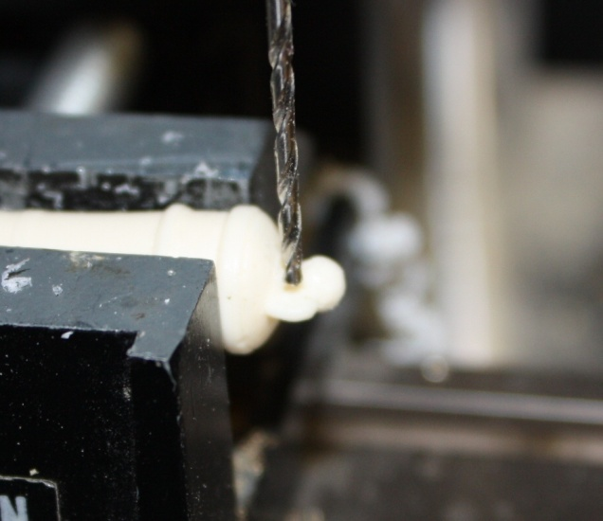
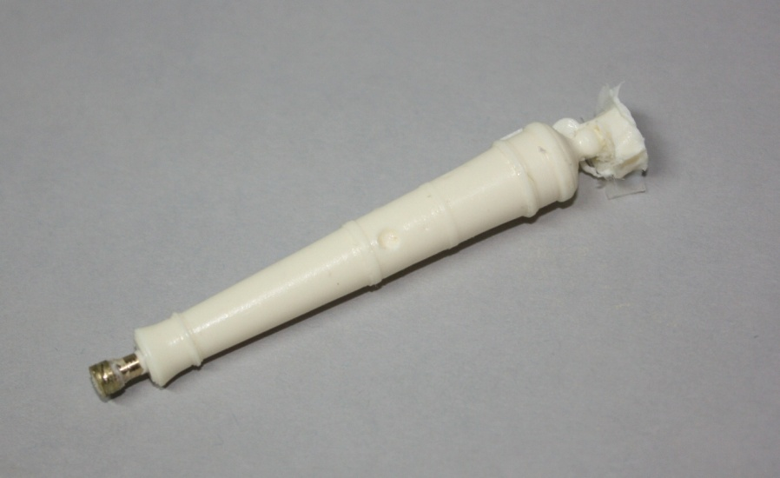
As a result, I spoke with a professional silicone mold maker and he convinced me to discard the entire idea of two piece molds and make a one piece mold. The results were quite good, and the mold making was far simpler. The master barrel should have the cascabel loop and the trunnion holes plugged with clay but left with a dimple to mark their locations. Protruding trunnions will hang up in the mold and the loop does not always form properly during the pour. The bore will be started in the cast part when the plug is removed from the barrel.
Silicones can be purchased from some hobby and craft shops, or directly from some manufacturers. The same suppliers will likely have a variety of casting resins if the model builder decides to use this material rather than metal. Some resins can be mixed with dyes to yield black barrels and others can be painted. Be sure to clean the barrels with solvent and use a compatible paint. As some solvents and paints may not work with the resin being used, always test a piece beforehand.
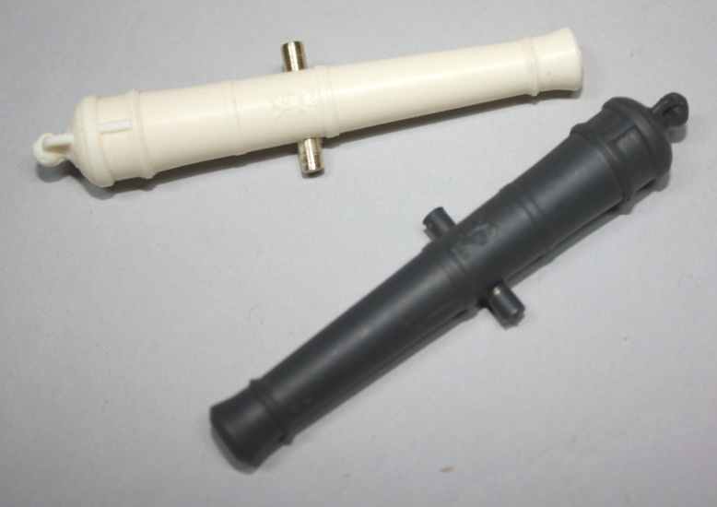
Once the master barrel is made, make a small wooden box with inside dimensions that are about 1″ X1″ by 3″ long. There is a support pin on the bottom to hold the master barrel upright and secure during the silicone pour. The wooden box should be well coated with a mold release of some kind. Liquid Vaseline or commercial mold release can be used. The sides and bottom are screwed together so they can be easily removed once the silicone has cured.
During the actual resin or pewter pours, if the mold seems to be a bit flimsy, remove only one side of the box and leave the silicone mold in the box during the pours and curing time.
The small plug that fits into the bore of the master will be used to form the beginning of the bore on the cast barrels. The top of the mold has a very small opening that can be spread open with a miniature funnel or piece of brass tubing while the resin is being poured.
Now the casting of the barrels can begin. A bag of small uncoated paper cups will come in handy to mixing each pour. They are a penny or two apiece and can be discarded after a single use. Follow the instructions for the particular casting resin being used. A fast curing resin is best for this application. Make the pour and remove the funnel. It pays to poke a piece of wire into the opening and move it around a bit to help any entrapped air come to the surface. The funnel is removed once the mold is full of liquid resin and before it cures.
Do not remove the barrel too soon as they may be soft and can easily be bent out of shape. Follow the manufacturer’s recommendations. To remove the barrel, it is a matter of pushing the piece up and through the opening at the breech end. The bore plug may come out with the barrel but can be removed for use on the next pour.
Once the barrel is removed, the flashing at the area of the cascabel can be removed and the barrel tidied up. The trunnion holes, cascabel ring opening and the bore can be drilled at this point. A properly sized piece of brass rod can be used for the trunnion.

