Building of the Lincolnville Wherry
Let me start out by saying I am a “somewhat” new modeler. I have built a few wooden model canoes but have never a planked boat. I choose the Lincolnville Wherry as it looked like a neat model and not too hard for a “beginner”.

As for the kit, it is very detailed the laser cut pieces are very precise and required very little sanding.
I did make a few “beginners” mistakes that, if I was building the wherry again, would pay more attention to. Below are some of my “shall we say” learning experiences,
The wherry is built on a jig. The instructions call for drilling holes in the Stem, Keel, and Stern sections and pinning these sections to the jig. For me it was really hard time getting the pins to be tight enough to hold the Stem, Keel, and Stern tight to the jig. Instead I choose to clamp the Stem, Keel, and Stern pieces to the jig. That seemed to hold them in place very well for the planks to be applied.

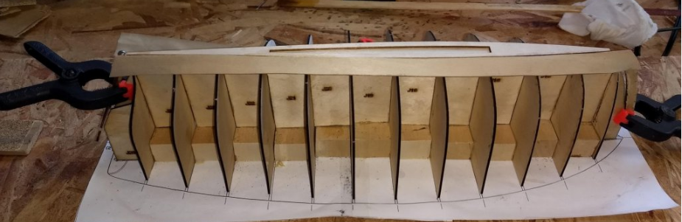

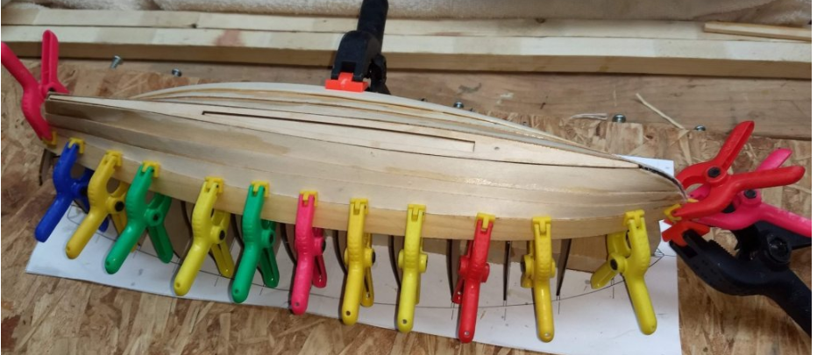

Planking the boat is very easy as the planks are very well cut… While the planks are numbered, for some of the thinner planks, there is a very subtle difference as to which end is the bow and which is the stern. With all the planks soaking in water, as I pulled each out to bend and glue to the jig, it was really easy to get mixed up and reverse the planks. “Ask me how I know”?
Be careful you keep track of the bow and stern section of each plank. Before you soak them, you might lightly mark and bow or stern sections so you can keep them straight.

When planking take extra care in ensuring the planks are tight against the jig. Otherwise when you take the boat out of the jig to work on the inside, the seats, kneeing board, and other inside fittings will need to be altered in order to fit the “new shape” of the hull. I should have payed more attention, as my planks ended up wandering from the jig and I did have to make some alterations.

Below is a look at the wherry from the inside with the seats, kneeling board, and ribs installed. The ribs, while very thin, once soaked in water, bend very easily and were no problem to install.
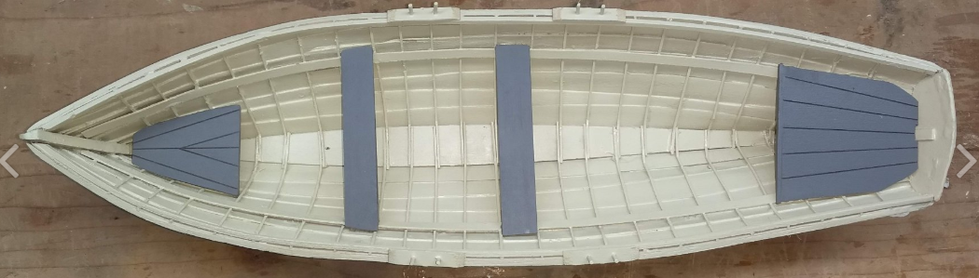

And final home above our fireplace. I ended up painting the wherry similar to the boats in the picture. The line that comes with the kit for the bow line seemed a little thin. Instead I used a candle wick for the bow line. It is braided and looks more to scale. The fishing net is really a think hair net.

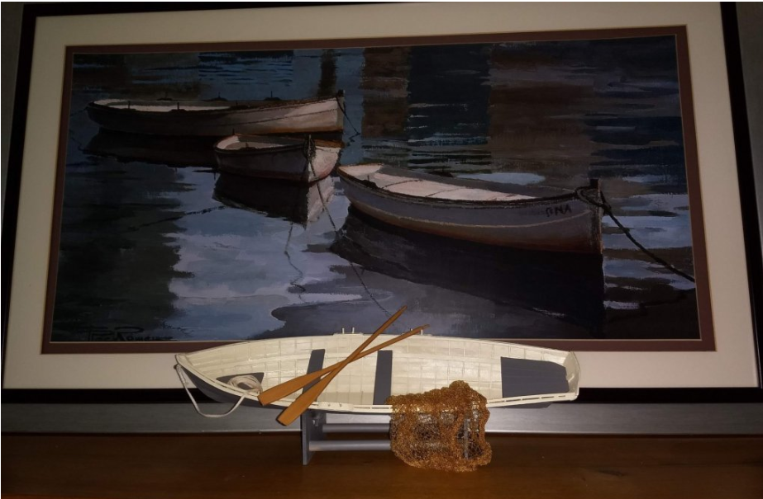

I really enjoyed this build and very proud of the end product. I would recommend the Lincolnville Wherry to any modeler just starting out or to the more experienced modeler who is looking for a small project that looks great. You will get compliments on it

