Philadelphia Ship Model Society
Participant’s Instructions –

Please Register Your Model at www.philadelphiashipmodelsociety.com/modelcon or email modelship@yahoo.com if you haven’t already so we can plan spacing and print out placards.

Date: August 6, 2022

Time: Setup 7:30am – 9:30 am
Display 10:00am – 5:00pm
Breakdown 5:30pm – until complete

Location: Battleship New Jersey
30 Clinton St
Camden, NJ 08103
https://www.battleshipnewjersey.org/

Model Onboarding: At the end of Clinton St. by the Battleship
There will be an elevator
Large and/or Numerous models/dioramas will be able to drive up the slip to the ship.
Assistance will be provided as needed to board the models

Free Parking: Along Clinton St

Parking is free along the right side of the street as you come in. Attached is an information participation sheet with other information, sorry I held on to it so long!

Arrival:
So, you'll arrive on scene based on the map (in the participation sheet) and line up along the left side to await your turn onto the slip if you need it. You'll temporarily park and walk up to the gate to check in, get your meal ticket, etc... We'll let you know when you can drive up to the ship on the slip based on traffic.

Your Turn:
You'll drive up to aft elevator if you're on the fantail or the forward elevator if you're in the Wardroom (by special request only). You'll park, unload your models up to the display area. Come back down, park your car and then come back to the ship. Anyone needing ambulatory assistance can be rendered through golf carts or someone can valet their car back for them.

Then have a donut and a coffee :).

Display Locations: Officer’s Wardroom (Air Conditioned)
Quarter Deck (Fantail) (Tented)

All the display areas are on the main deck, accessible by wheelchair
Elevators available
Bathrooms available onboard the ship.

Food: Outside food is permitted
Free lunch voucher in ship’s mess (Ballpark style food)

Vendors: Topic appropriate vendors permitted
Battleship open to sponsorship arrangements (Details by request)

Volunteers: Access to self-tour the ship
You can bring up to 3 guests

Questions/Need Help: Call: Jim Wheeler 215-901-3527
Joshua Fichmann 609-760-4727

We look forward to seeing you at the event!
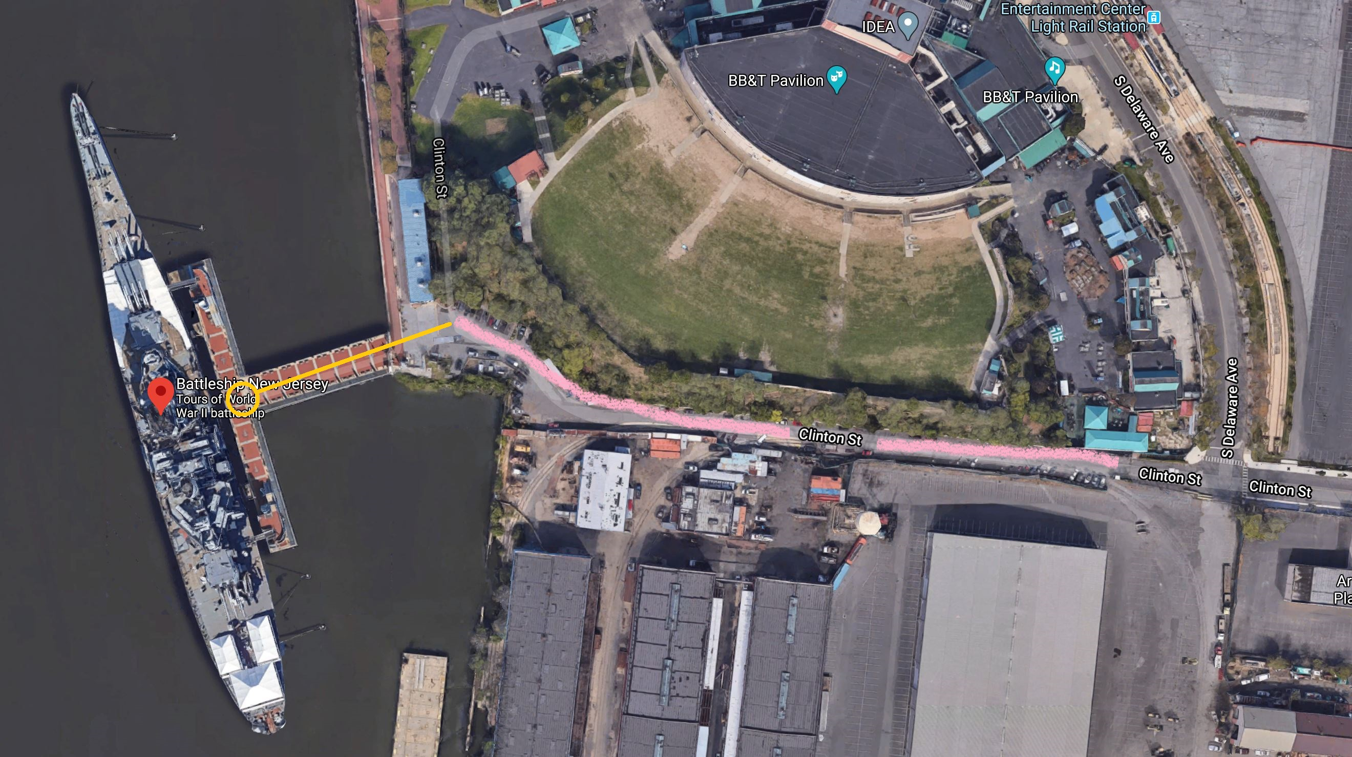
(Wardroom)
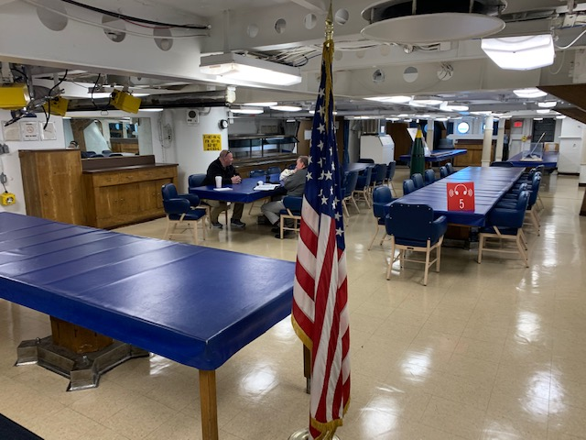
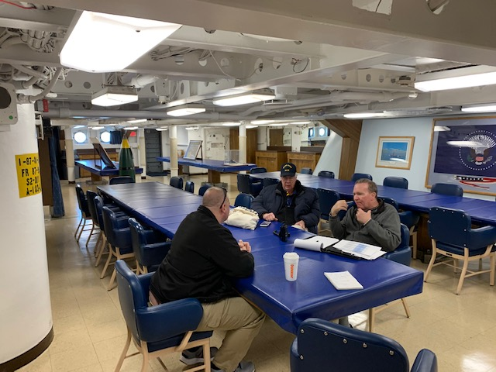
(Fantail)
