Reading/Decoding Mamoli Rigging Charts
Bill Edgin (ModelShipWorld.com)
I spent quite a bit of time learning how to read the Mamoli rigging plans. Since there were no explicit instructions on how to interpret the drawings I spent a great deal of time looking through them before I figured out their method. Once I did, it was pretty straight forward. I thought perhaps others might find this useful. Perhaps this is how all rigging plans are done. Since the Connie is my first kit, I have no reference. I also need to mention this kit was purchased in 1991 so it may have changed. However for what it is worth here is how my plans are interpretted.
There are two tables on each rigging page. The first table is on the right and lists all the parts, this is standard on all the Mamoli pages. However the second table, placed directly to the left of the first left is only on the rigging pages. the tables are not really labeled or numbered but they are consistent on how they arrange them. The only difference is where they are placed on the plan.
For this illustration I will show how to interpret the rigging on the Mizzen (part o552) circled on the drawing. Here is a copy of the appropriate section from the plans:
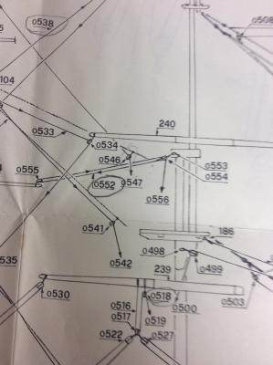
This shows a rigging set running from the tip of one of the Mizzen booms to the cap just above the Main Mast's fighting top.
First we need to see what the parts are for this rigging. The size of the line, the size of the blocks, etc. For this we turn to the right most table on the plans. This table is on all of the plans an lists the all the parts of the ship as well as the various sizes. In some cases, the part number might refer to a different page of the plans if the part was installed much earlier so you might have to refer back to another page of drawings. Here is a copy of the section in the table dealing with the rigging for this piece.
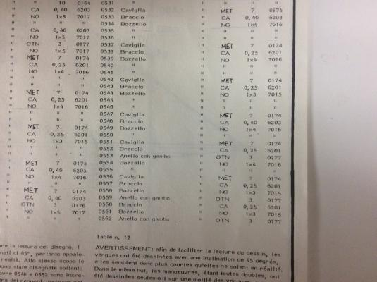
We can see here that 0552 (o552 in the above drawing) is labeled Braccio (which means "Arm"), the second column tell us that the amount is the same as the above parts, which is 2, although you can't see that in this photo. More importantly, the second column from the right says 0,25, which means this is the 0.25mm line. So now we know the size of the line, let's see where it runs.

The second table directly to the left of the parts list table contains the order a line runs by listing the part numbers in the order they go starting at the lines termination in the rigging and ending at the termination on the deck. The entry for 0552 shows 0552 D = 0554+055+0554+0556 (fig 10). This is chock full of valuable information. Ignore the pencil marks; that is how I track when I install a line. First the line will start at part 0554. We can look on the first chart and see 0554 is a block (Bozello) that is made of walnut and is a single 4mm block (1x4). This also refers to a figure (fig. 10) for more information. This figure is shown below:
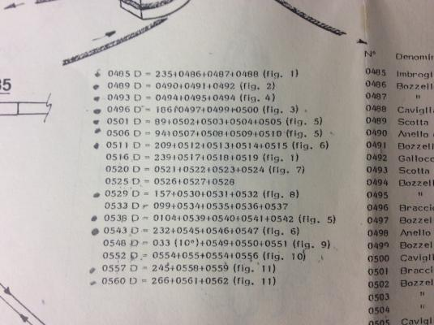
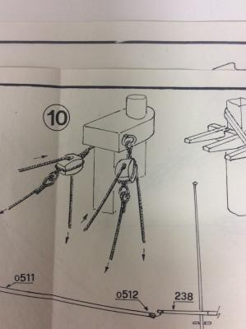
This shows the manner the blocks are attached to the mast cap. If we want more information on the rings we can refer back to the first drawing of the rigging and see this part is 0553. Referring back to the first table we can see that part 0553 is a 3mm brass eye ring (Anello con Gambo = Ring with shank) the OTN refers to a table in the general instructions that shows it is made of brass.
So after the two rings are installed on the cap, the block is added with the .25mm line attached to it. This then runs to the block 0555. The table tells us this is also a 1x4 walnut block that is attached to the end of the spar. The line then returns to 0554 and runs toward the deck. As a note here, if the line also went through the fighting top, that too would have been listed in the order the line ran through it. In this case it does not but goes directly from the block (0554) to part 0556, which table 1 informs us is a belaying pin (Caviglia). The termination point is shown not only in the table but also in the rigging diagram. The sheet also has a diagram showing the layout of the termination points when viewed from the rigging.
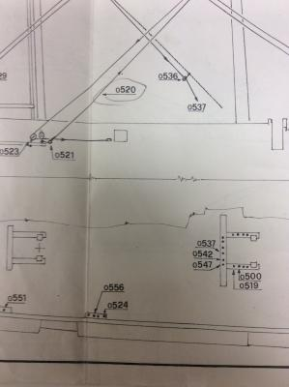
From this we can see that 0556 is the third belaying pin aft in the 4 pin belaying rack located on the starboard side between the two fife rails. The port side has a matching set for the matching mirrored rigging set.
So that is it. A further note on terminations, if a line terminates tied to a side shroud, the shroud grouping is noted and it is numbered from front to back. So the rigging drawing would show the shroud set from the side and give you the number it would be referred to as.
This would look like the following:
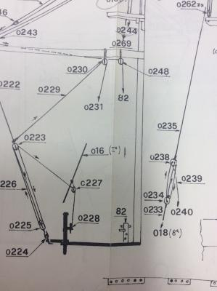
Any lines terminating on one of these shrouds will be labeled 16(x) with x being the number of the shroud from the bow. The following drawing shows how this shroud is referred to in the rigging drawing.
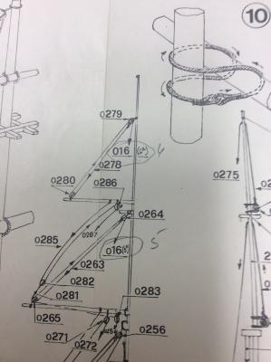
So this shows the top line would terminate on shroud set 16 on the 6th shroud. The one below is marked to terminate on the 5th shroud. It is hard to read but you can see my pencil marks to the left of the number.
So this is how the rigging plans work. I stopped working the lines from the top of the table down since they tended to number the lines from the bottom up. This meant that the top lines which normally run down the center of the ship, had to be fished through the other lines. However, other than that, I have been following these diagrams pretty much as they are drawn.
One other note: Sometimes they will have a part shown with Dx or Sx (or both) next to the number in the plan. Dx means Starboard side, the D = "Dritta or Starboard". Sx means Port side S= "Sinistra or Port".

