The super-beginners guide to stropping and whipping blocks.

In the middle of building my first wooden plank-on-plank model (H.M. Pickle) all was going well until I came across the wonderful instructions “two copper eyelets can now be fitted to the main mast with their respective blocks”.
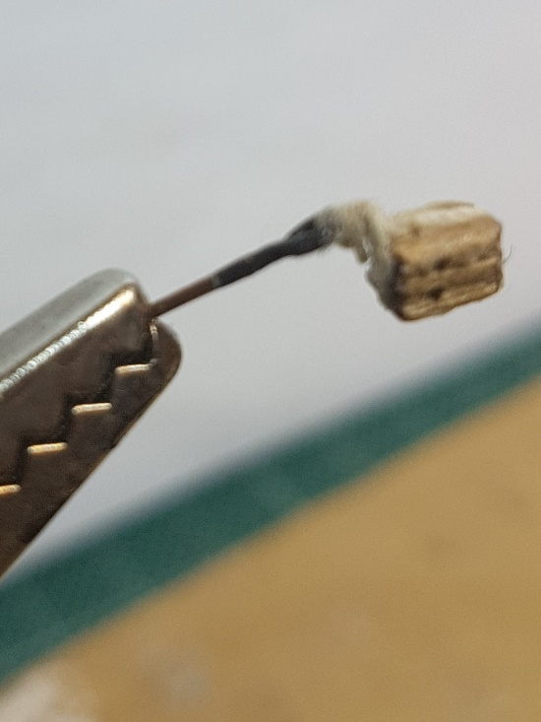
Great I thought, and how am I supposed to do that?

After a lot of (not very good) research, I thought I had worked out what to do and so proceeded to ‘attach’ my first block. Result? Terrible.

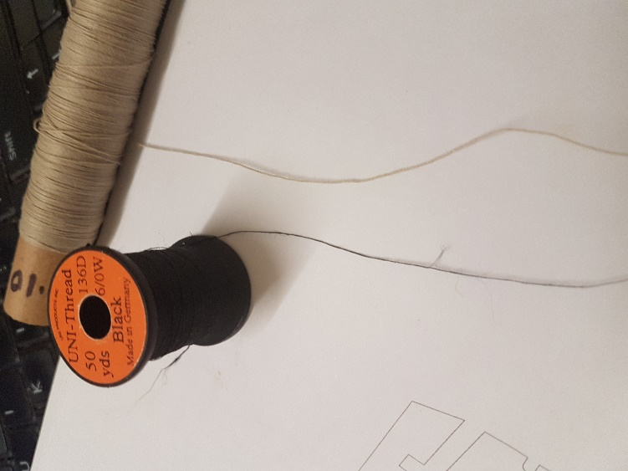
This was really not good enough and after more research realised that I needed to whip the cordage tying the blocks if they were to be any good. After all, I had whipped enough rope ends on sailing dinghies so what could be so hard??

I found several modellers recommending the twine that fly-fishers use to construct their flies and after a little digging found a great company that provided the right type of twine. A couple of days later, the twine arrived and the 0.07mm twine can be seen alongside the kit’s 0.01 mm twine.

So now I had to find out how to strop and whip my blocks. After further research, I found great examples of videos showing how to strop blocks, or strop blocks and attach blocks to spars but no reference to attaching to an eyelet.

Following the videos and descriptions, I attempted to build my own but without any success. No matter how much I tried, it just didn’t work and my methods weren’t logical either.

Then I decided that if I couldn’t understand how to do this on a model then perhaps, I should try to strop and whip a full-size block, except that funnily enough, I didn’t have one.
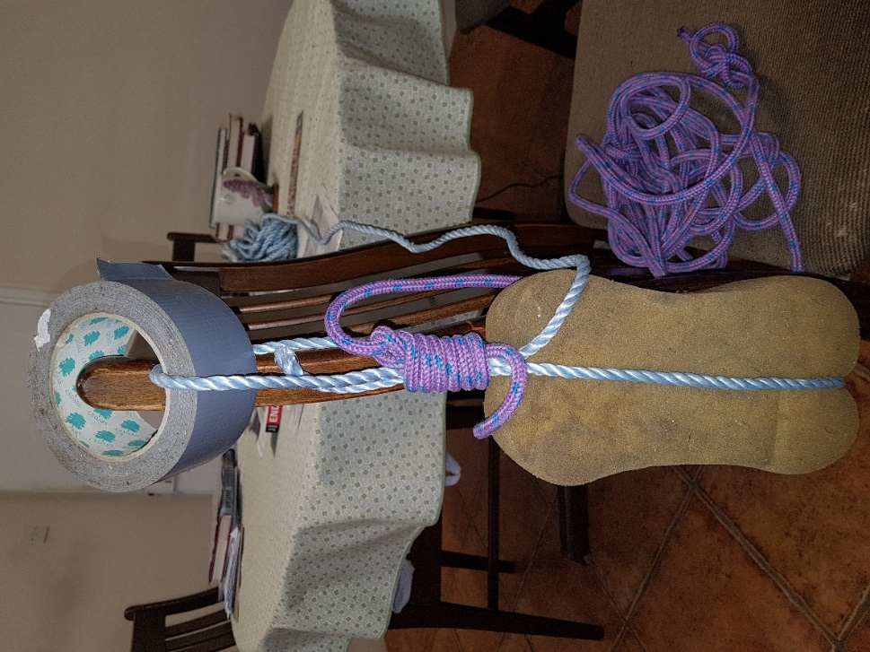
I then had the bright idea of using a car sponge to represent the block, a roll of tape to represent the eyelet and two different ropes to represent the stropping and whipping ropes.

Sounds strange, but after a few attempts, it worked!!

Great, back to the model then..

OK, so first the tools I used.

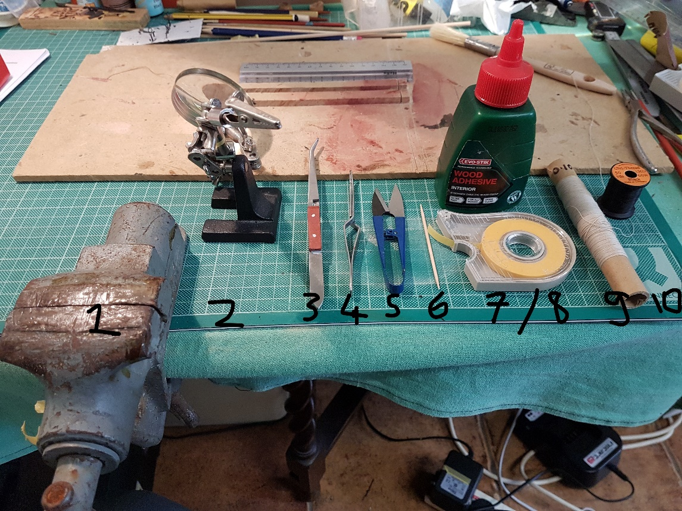

1: A small table vice 2: Jeweller’s glass/clips 3 & 4: Tweezers 5: Scissors 6: Toothpick
7: Masking tape 8: Standard Wood glue 9: Kit supplied 0.10 mm thread (for stropping)
10: 0.07mm twine for whipping

Note. All threads in the following pictures appear with long ends as I didn’t cut any until I’d completed everything.

Step 1: Stropping the block

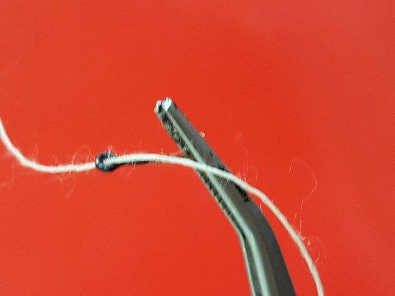
A: I clamped the larger tweezers into my vice and then clamped the eyelet into the tweezer jaws. I then took my 1mm kit thread and threaded this through the eyelet, pulling the thread through by around 10-15 mm and fixing the end in the Jeweller’s crocodile clip jaws.

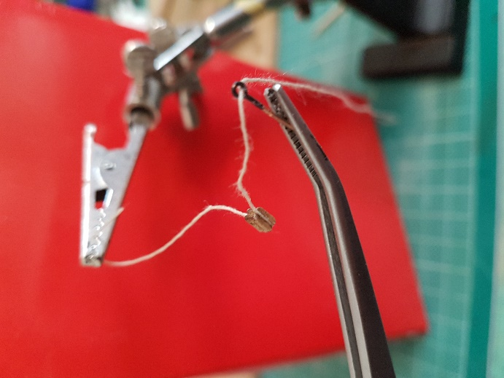
B: Next I used the second pair of tweezers to hold the block and using the toothpick, added a little white wood glue to the block’s lower and side grooves. Finally, I took the thread and attached it to the block.

I found that by pulling the two ends of the thread together to the top of the block and pinching it tightly with my fingers helped to secure the thread nicely.

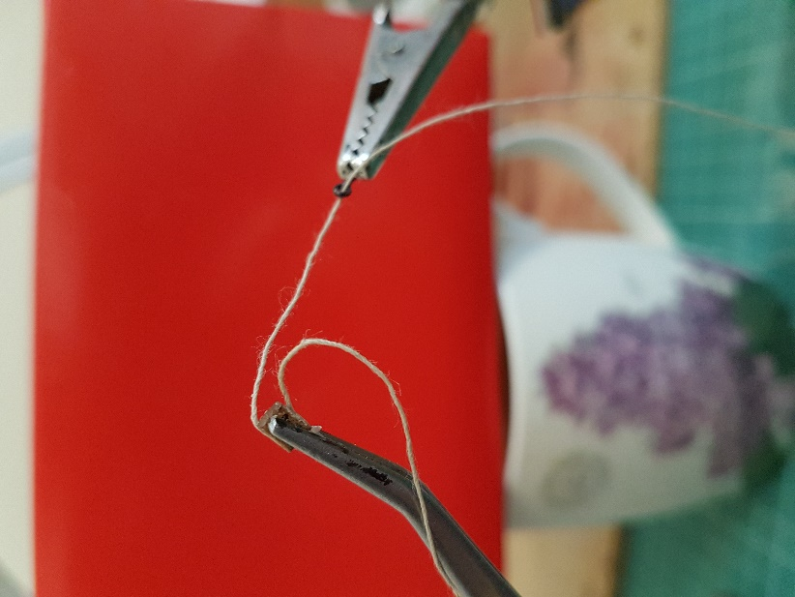
C: The next step was to transfer the block to the tweezers made fast in the vice.

Important here was to make sure that the block was the correct way up so that the shorter length of twine was at the bottom (seen on the left of the picture).

At the same time the eyelet was made fast in the jaws of a crocodile clip. The longer length of twine can be seen as previously threaded through the eyelet.

Note also that having a mug of tea to hand is mandatory for this task!

Step 2: Whipping the Stropping
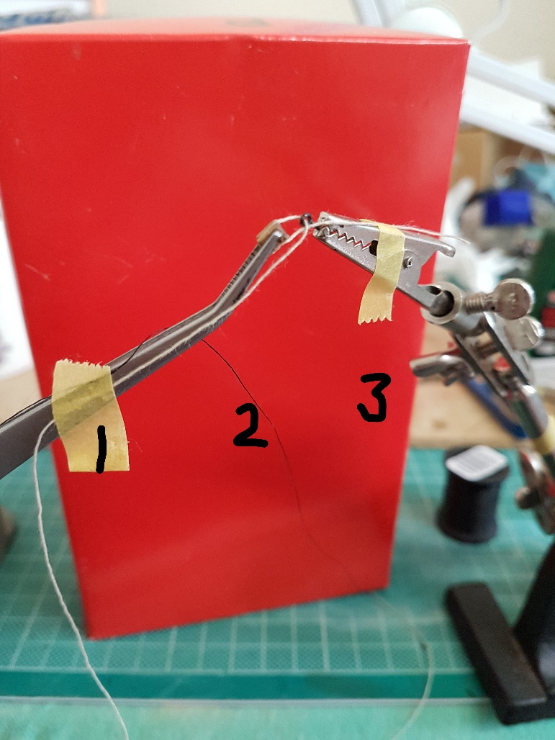
D: After tightening the threads and moving the Jeweller’s clips together, the next step was to secure the threads.

I had already prepared 3 pieces of masking tape ready for the task which is a lot easier than trying to cut off pieces whilst trying to hold threads in place.

1: The long end of thread still attached to its reel and kept in place with tape.

2: The end of the whipping twine still attached to its reel and kept in place with the same piece of tape.

3: The short end of thread and kept in place with tape.

Note that the tape is attached firm enough to hold the thread in place but on the other hand, loose enough to allow the thread to be pulled through (whilst hold the tape down!) to bring the block and eye closer together when needed.

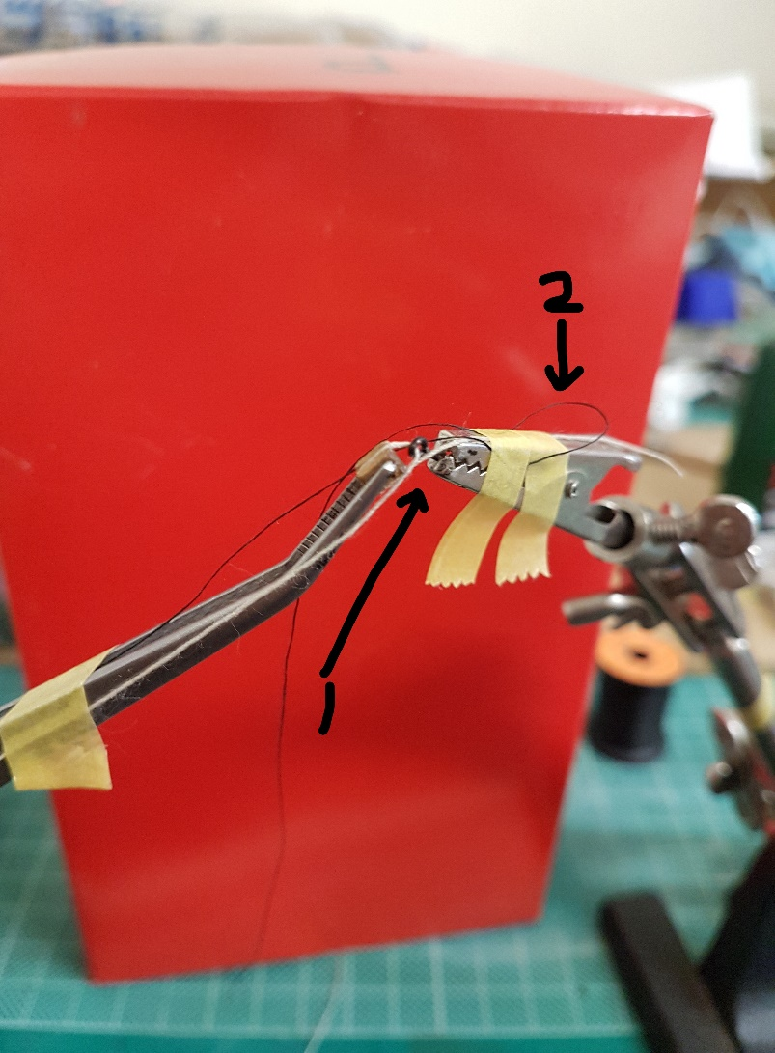
E: Now take the long, un-attached end of the whipping twine, make a loop and make the twine fast as shown at 2, leaving the longer length free. Do not tape the loop itself as it will be needed to complete the whipping!

The whipping is now done at the point shown at 1. Note that in this example, I needed the block to be quite tight to the eye so adjustments need to be made if the distance is longer. After any final adjustments of the space between your block and eyelet, take the free end of whipping twine, measure a workable length and cut from the reel.

Now, take the twine from underneath, bring it up over and back down and carefully pull tight. You will see that the two threads will come together between the block and eye. I use the toothpick here to nudge the twine into the correct place. After the first twist, repeat 5-6 times making sure you keep the twine tight.

Finally, take the end of your twine, thread it through the loop made at 2 from underneath and keep hold of it and release from the tape. Now release the other end of the twine from where you fixed it in step D, and slowly pull. You will see the loop tighten and eventually be pulled underneath the whipping.

Step 3: Finishing off

Now all that remains to do is tidy up. Release the block and eyelet, then all the threads from their tapes and carefully (very carefully!!) cut the thread and twine.

The next choice is whether to add a dab of glue to the whipping.

Personally, I know the whipping will hold and also I find that by adding glue to the whipping, the whipped section will stiffen so that the block doesn’t hang at a natural angle anymore.

The final 2 pictures show the finished block and the new block on the left, side by side with my first attempt!!

